**PROGRAMS**

**Week - 1**

1. Write the required HTML5 code to create an online feedback form for ISC students. The form should looks like the following screenshot.

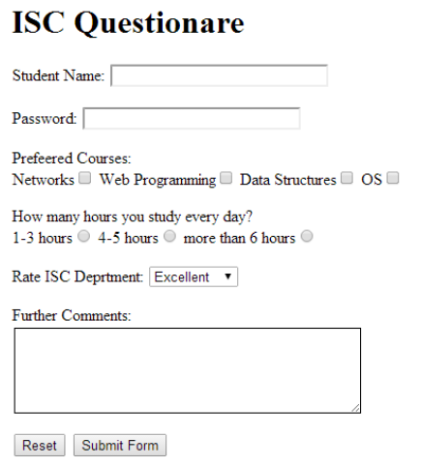

**2.** Write the required HTML5 code to create an online user registration form which looks like the screenshot attached

